Project Design Phase-II Technology Stack (Architecture & Stack)

|  |  |
| --- | --- |
| Date | 1 NOVEMBER 2022 |
| Team ID | PNT2022TMID41904 |
| Project Name | Project - IOT Based Safety Gadget for Child  Safety Monitoring and Notification. |
| Maximum Marks | 4 Marks |

# Technical Architecture:

The Deliverable shall include the architectural diagram as below and the information as per the table1 & table 2

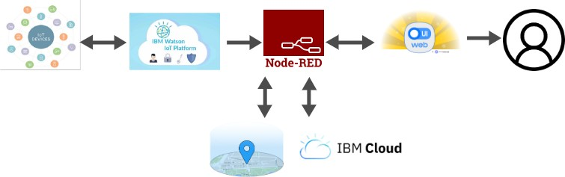

# Table-1 : Components & Technologies:

|  |  |  |  |
| --- | --- | --- | --- |
| **S.No** | **Component** | **Description** | **Technology** |
| 1. | User Interface | How the user interacts with the application . Web UI | App development |
| 2. | Application Logic | Logic for a process in the application | Python |
| 3. | Database | Data Type, Configurations etc. | Cloud database |
| 4. | Cloud Database | Database Service on Cloud | IBM Cloudant . |
| 5. | File Storage | File storage requirements | IBM Block Storage or Other Storage  Service or Local Filesystem |
| 6. | Cloud/Server | 1. Cloud server description 2. Local server description | Cloud foundry |
| 7. | Protocol | How data exchange on web | HTTP |

**Table-2: Application Characteristics:**

|  |  |  |  |
| --- | --- | --- | --- |
| **S.No** | **Characteristics** | **Description** | **Technology** |
| 1. | Security Implementations | List all the security / access controls implemented, use of firewalls etc. | We are using the IBM cloud, so for every instance of time it updates the current location of the children to their parents/caretakers. |
| 2. | Scalable Architecture | Justify the scalability of architecture (3 – tier,  Micro-services) | The technology is used to monitor and  send alert notification. |
| 3. | Availability | Justify the availability of applications (e.g. use of load balancers, distributed servers etc.) | We are using the geofence,a service that triggers an action when a device enters a set location |

|  |  |  |  |
| --- | --- | --- | --- |
| **S.No** | **Characteristics** | **Description** | **Technology** |
| 4. | Performance | Design consideration for the performance of the application | We are using HTTP, for every second the location of the children are sent to the parents. |